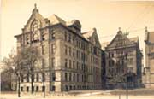
PSYCHOLOGY NIGHT APPLICATION

The 13th annual Psychology Night will be on Monday, May 19th 5:00-7:00 on the Lincoln Park Campus in Student Center room 120 A & B. All undergraduate and graduate students are invited to submit applications with preliminary or completed studies to Dr. Cotler by Monday, May 5, 2008. Contact: scotler@depaul.edu

Project Title
Author(s)
(Authors should be listed in the order of their contributions to the project)
Contact Person
E-mail and Phone Number
Faculty Sponsor
(If applicable)
Research Area
Abstract/Brief Description
(To be printed in the program, use extra page if needed)

