Getting Paid to Cause Trouble:

Careers in Social Justice
Sponsored by the Chicago Center for Working Class Studies
and the Roosevelt University Mansfield Institute for Social Justice

Saturday, April 5
11:00am – 1:00pm
lunch included

Roosevelt University

CPA Building, 18 S. Michigan Ave.

(midway between Madison and Monroe)

1st Floor Gage Gallery
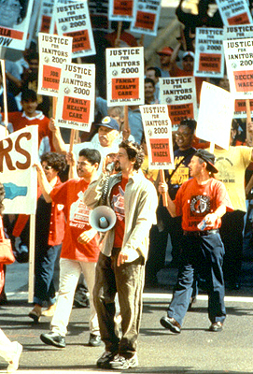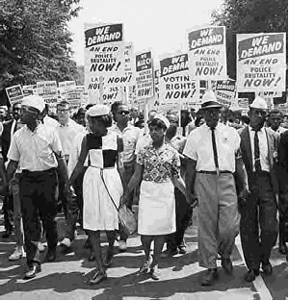

Come meet organizers from local community organizations and unions “walking the walk” and learn about careers for young folks in social change!
Free and open to the public. Lunch will be served.

Please r.s.v.p. to Carrie Breitbach at cbreitba@csu.edu

Organizers from Illinois Action Now, AFSCME Council 31, UNITE HERE!, the IEA-NEA, Brighton Park Neighborhood Council and other unions and community groups will be here to talk about jobs and internships available NOW!

For more information about CCWCS: www.workingclassstudies.org

