Orientation to BlackBoard
March 7, 2003

Sharing documents with students and easy email to the class or selected students

- go to https://oll.depaul.edu/ and login
- choose your course and the next screen is what you will see next
- 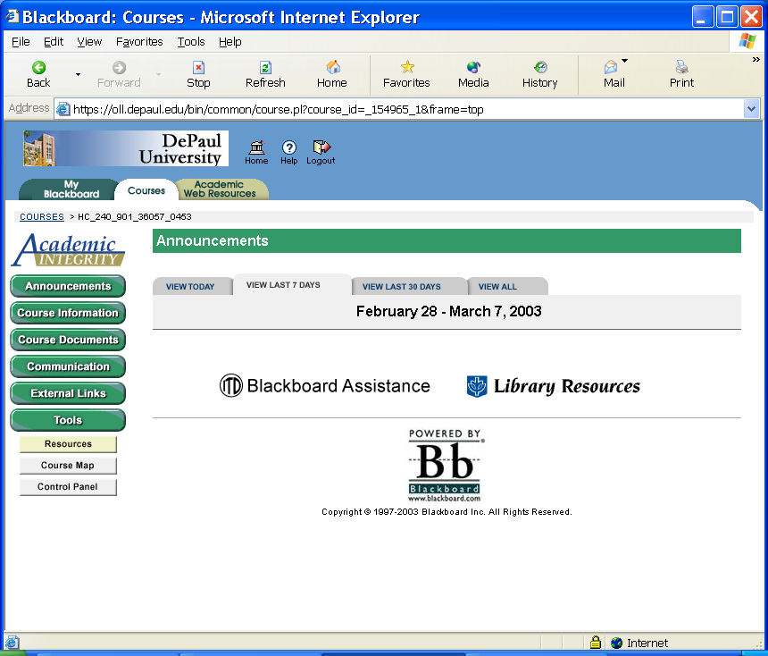

The control panel is where you make things work – go there first

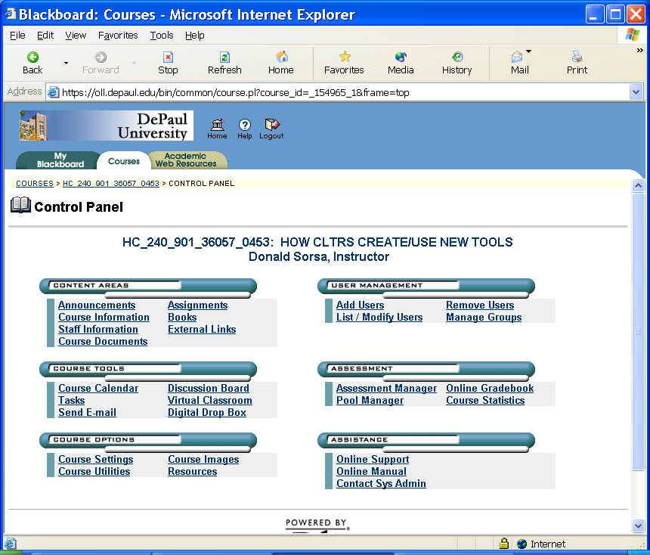
Adjust Course settings first

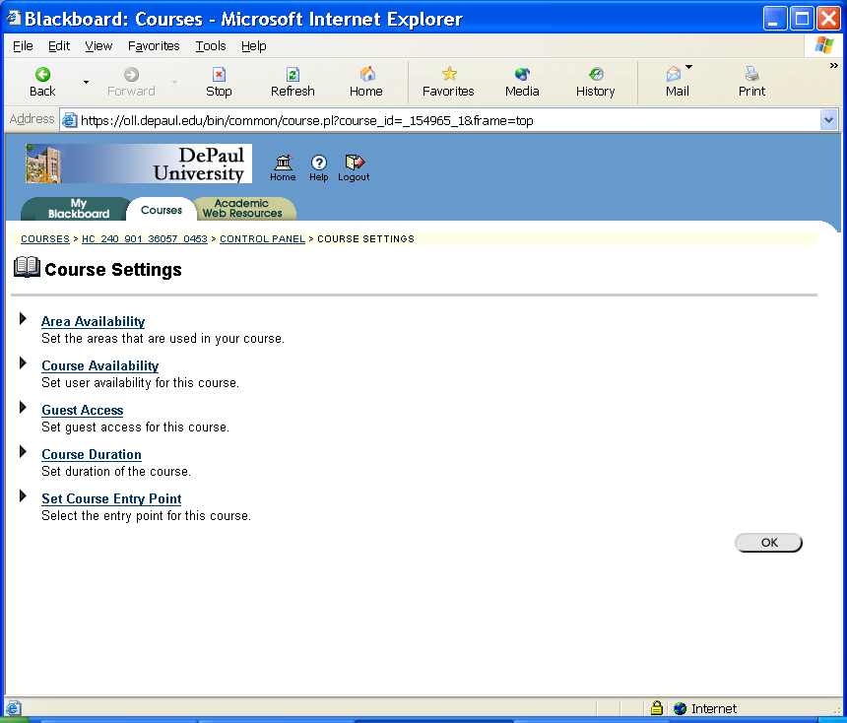
Set up access
On next screen, I suggest ENABLE only the following

COURSE DOCUMENTS

COMMUNICATION

GROUPS

EXTERNAL LINKS

Scroll and Click Submit
On the next screen
(not shown here)
ENABLE

COURSE DOCS

COMMUNICATION

GROUPS

EXTERNAL LINKS

Scroll and click SUBMIT

Return to Control Panel to upload the syllabus and other documents

The next screen will allow you to add documents.
Return to Control Panel to Add groups and student access

The next page shows you how

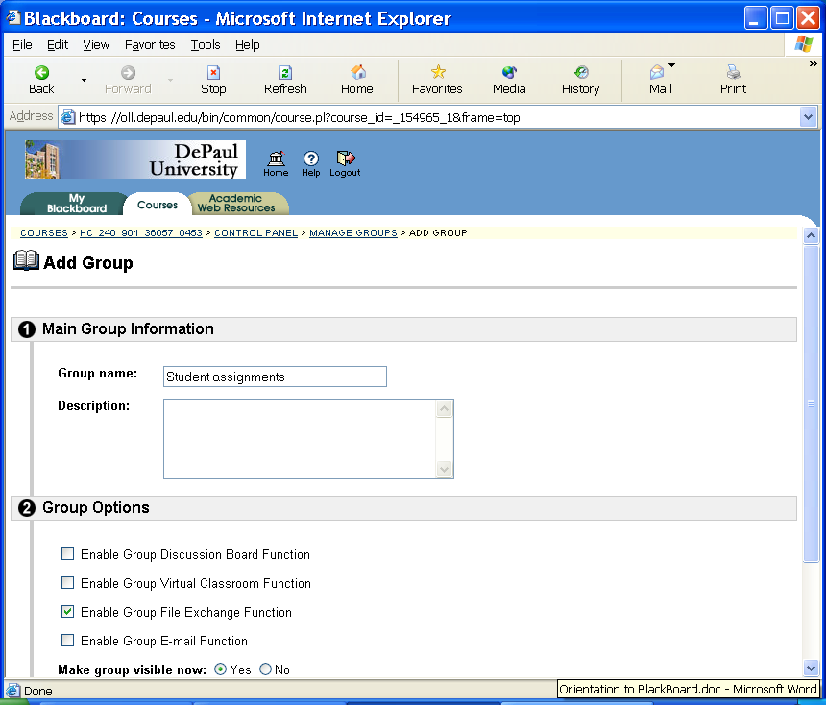
Scroll and click SUBMIT

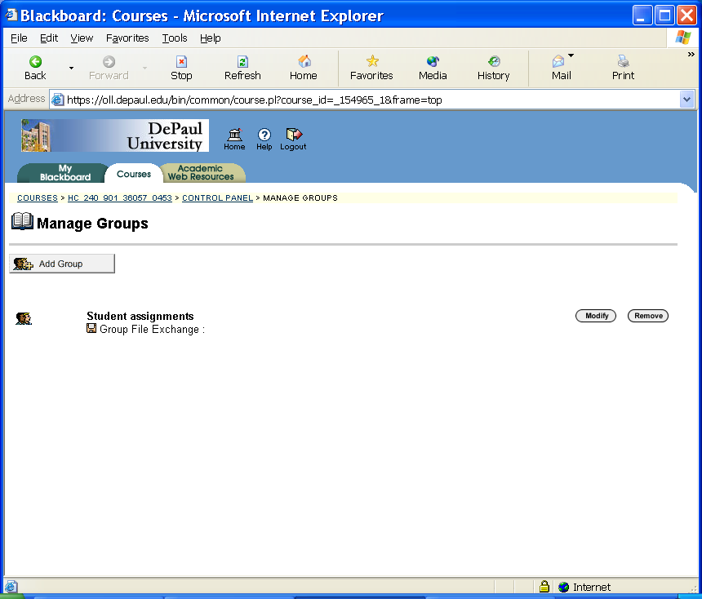
On the next screens, click ADD USERS

Then click SEARCH
and you get a list of all students
Note cookie crumbs

These changes will
- give students a place to upload their assignments and read other student assignments
- allow you to easily send email to everyone in the class
- allow you to post external links (websites) if you choose
- allow you to post course documents and handouts

One last step, making the BlackBoard visible to your students

Go to the Control Panel
Course Settings
Course Availability

