Web Page Layout Using CSS

Yosef Mendelsohn – IT 130

Disclaimer #1: CSS positioning is fun and useful, but can also be very confusing because there are so many different ways of accomlishing a given task. It can also be inconsistent in terms of how displays are rendered by different browsers. Entire books have been written about it. The 1-2 lectures that will be allotted to it in this course are intended only as an introduction. If you wish to become more proficient, there are numerous books and websites devoted to the subject.

Disclaimer #2: Recently I told you that we will be attempting to move away from inline styles and towards using classes or embedded/external styles instead. In these notes, however, I will frequently make use of inline styles only because it is easier to demonstrate the techniques we are applying rather than having to go back up to the <head> section each time.

Introduction
As you have seen this far in the quarter, simply displaying items on a web page is not difficult. However, placing items exactly where you want them can be very tricky. For example, consider this screenshot taken from DePaul’s CDM site below. In particular, note:
- The title of the page spanning across the top
- A series of navigation links in a column on the left side
- Some content / narrative text in a middle column
- A right column containing other links

Even a relatively straightforward design such as this one can be surprisingly tricky to achieve.

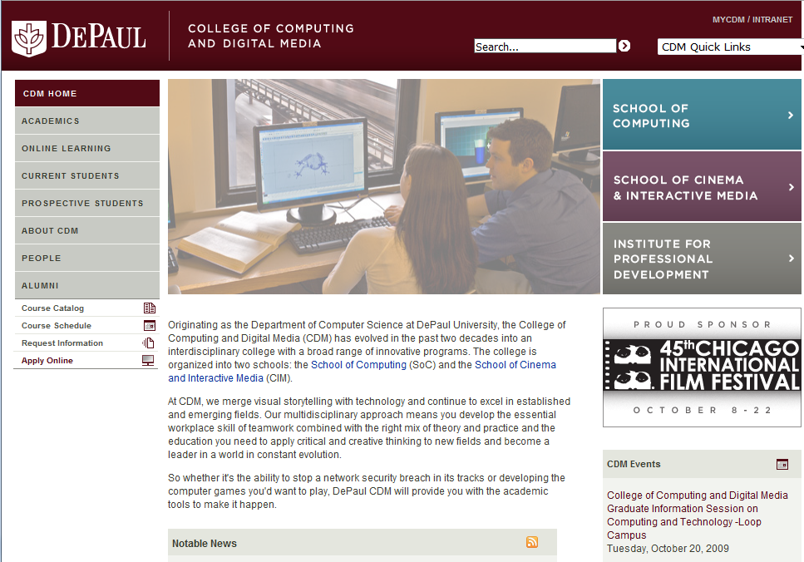

Web designers have used—and continue to use—all kinds of tricks and “hacks” to lay out content on a web page. One of the more popular tricks/hacks has been to use HTML tables. Although it remains very common, it is considered a misuse of “pure” HTML principles. In addition, it is being increasingly replaced by CSS. In this class, we will instead, learn about the fundamentals of CSS techniques.

The Box Model
The first step in learning to create layout using CSS is to understand the “box model”. The box model describes a way of thinking about elements on your page. Specifically, you should view the model with the following characteristics:
- Each element (e.g. a block of H2 content, a DIV section, a UL list, etc) lives inside its own box
- Most boxes (there are exceptions) take up an entire line spanning the width of their “container” (e.g. the browser window)
- Each box holds: Content (e.g. the text inside the H2 tags), a Border, Padding, and Margins

Although things like padding, margins, borders don’t mean much to you at the moment, the advantage of having these properties is that the web designer (you!) can manipulate them to control the appearance and layout of your web page.

By default, things like borders, margins, and padding are invisible. In the diagram below, you can see some content (the text that says “This is an element.” This diagram also shows its surrounding padding, border, and margins. The border is highlighted in this diagram because it can be made visible on a web page. The margins and padding can be used inside a web page, but are invisible.

Also recall how boxes take up the entire width of their container (e.g. the browser window); in this case, the width has been shortened to take up less space.
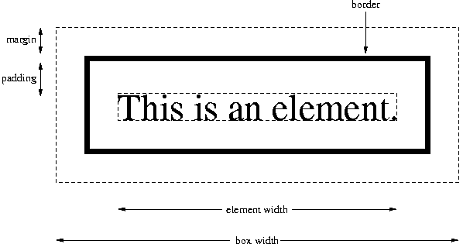

We will spend additional time discussing padding, margins, and borders a little later on.

Inline vs Block Level Elements:
In addition to studying the box model, it is also necessary to understand the concept of inline v.s. block-level elements. The main difference is that any “block-level” element places a new line before and after the content. This is why whenever you use one of your H tags, it always shows up on its own line. In other words, the moment you type in an H tag, you get a new line both before and after the content. In contrast, inline elements do NOT place a new line before and after the tag.

The other difference is that block-level elements conform to the box model in ways that occasionally do not apply to inline elements. For example, the box of a block-level element spans the entire width of the container, or, “containing element” (discussed later). Typically, the containing element refers to the browser window.

Here is a partial list of inline elements:
- a
- em
- strong
- img
- span

Here is a partial list of block-level elements:
- body
- div
- p
- h1-h6
- form
- ol / ul
- li
- table

Styles that can apply to both block-level and inline elements include:
- font
- color
- background
- borders

Styles that can be applied only to block-level elements include:
- *margins
- *padding
- width

*Actually, you can apply padding and margins to inline elements—but only right and left. You can’t apply margins above/below the element.

Ecumenical Elements – Converting between Block and Inline:
There may be situations where you would like to make a block level element behave like an inline element or vice versa. You can do this using the ‘display’ property like so: display:block or display:inline

As mentioned above, every box has various properties and characteristics that you can manipulate such as width, margins, and padding. For example, by default, a block-level element’s box spans the full width of the web page. Try placing some code inside an <H> tag and apply a border around it. You’ll notice that even if your content has only a couple of words in it, the content still occupies the entire width of the page:

<h1 style="background-color:red">Welcome</h1>

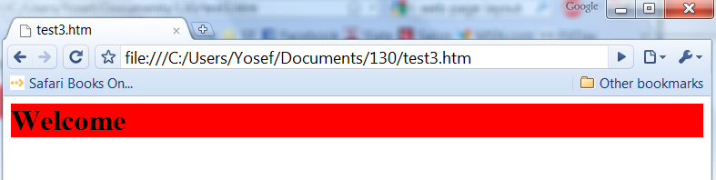

However, because ’H’ elements conform to the “box model”, we can do things such as adjust the width of the element:
<h1 style="background-color:red; width:150;”>Welcome</h1>

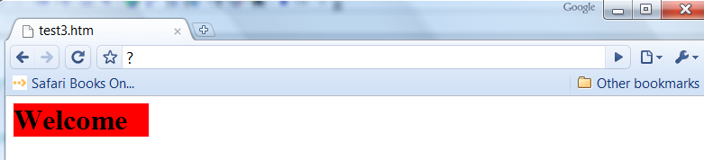

Below is a page on the French and Indian War with some content taken from Wikipedia. We will use this page to continue our exploration of layout techniques. In this example, I have
- Placed the heading “French and Indian War” inside an <h2> tag
- Applied a width, background color and border to it.

Here is the complete embedded style:
h2 { background-color:black; color:white; border:2px solid #FF9933; width:500; }

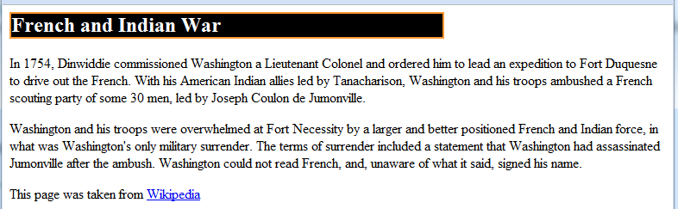

When dealing with boxes, two important and useful properties to become familiar with are padding and margins. We will not spend a great deal of time discussing padding and margins here, but they will become important if and when you spend more time trying to finesse layout using CSS. We will play around with them a little bit during class, but otherwise, I’ll leave it up to you to investigate further.

One other significant advantage to block-level elements is that we have various methods of positioning them in different locations within the browser window. Some of these methods are considered “hacks” but are still widely in use. There are also various methods that are not yet in widespread acceptance, but are being encouraged such as the use of CSS tables (not to be confused with HTML tables). We will not discuss CSS tables here. For now, we will limit ourselves to an overview of the better known methods used for CSS layout known as:
- floating
- relative positioning
- absolute positioning.

A Useful Tip
Of all the tips that I may give you in this document or during lecture, this is the most important: The moment you begin experimenting with layout on your page, you should ADD A BORDER to EVERY element that you are planning to lay out on your page. Initially it will make things pretty ugly. However, borders make it tremendously easier to see the effects of your manipulations. Visible borders also help you evaluate what elements outside of the manipulated element are doing. When you are are done, you can simply remove some or all of the borders.

Rather than adding the border property to each of the many elements that you are moving, there is a nice shortcut that you can use. Recall the technique whereby you can add multiple styles to several selectors at once:
h1, h2, h3 { color: green }

Well, you can use this technique to apply to several selectors or sections of your page such as in the following:
div, p { border: 1px solid red }

Setting Width and Height of an Element
One of the first techniques we’ll describe is the use of height and width properties. You will initially find that you won’t use the height property very much. During the early phases of design, the width property is more important (and less troublesome) than height.

Consider our page on the French-Indian War. I will take our first paragraph and apply a width to the <p> tag around the first paragraph of content. I’m also going to apply a border so that you can see exactly the size of the box. Notice how the second paragraph, which does not specify a width spans the full width of the page. So the point to remember here is that all block-level elements (such as the p tag) span the full width of their container unless constrained by using the ‘width’ property.

<p style="width:400; border:solid;">In 1754, Dinwiddle commissioned Washington....

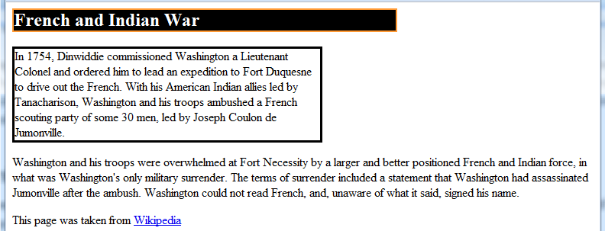

Now let’s suppose you wanted the entire textual content of your page to be limited to 600 pixels wide. (By textual content I mean all of the “words” –NOT including things like title, table of contents, footer, etc) This can be easily accomplished by:
- Having a <div> section surrounding your main content
- Setting a contextual style for that particular div section (based on its ID) to the desired width

The HTML:
<div id="maincontent">
<p>In 1754, Dinwiddie commissioned Washington.....

The contextual selector (from up in the <head> section):
#maincontent { width:600; border:1px solid; }

The result:
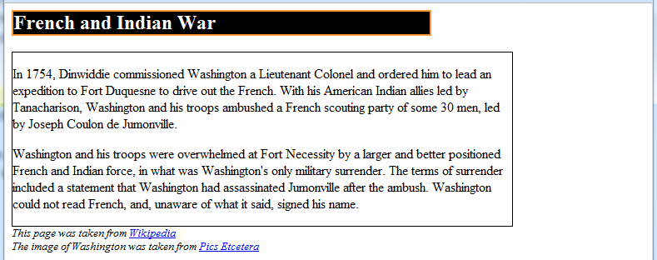

REMINDER: Note how I include a border. Remember to use borders constnatly when experimenting, testing, practicing, etc. You can easily get rid of the border once you’re done.

Specifying width using relative sizing:
A relative size means that you specify a size relative to the container. (Recall that the “container” typically refers to the browser window). For example, instead of specifying a width in pixels, you might specify it as a percentage. This way, if the user enlarges or shrinks the window, the box will enlarge or shrink with the window. Here is the syntax – you should certainly experiment with it on your own:
#maincontent { width:50%; border:1px solid; }

There are advantages and disadvantages to using relative sizes. For now, we will stick with absolute sizes. (e.g. pixels as opposed to percent)

Padding:
In the display above, note how the text inside the first paragraph’s box is flush up against the left border. This is where understanding the box model becomes useful. Padding refers to the white space between the border and the text. (However, remember that borders are invisible by default).

The default value for padding is ZERO pixels In other words, text will be always flush against the border. Most of the time you won’t have a problem with this since most web designers keep the border invisible. But if you choose to include a border, you may wish to give your text a little bit of “breathing room”. In order to do so, you can add a few pixels of padding using the padding property. You can even set padding for all four sides of the box individually (using different values for each).

As an example, below I’ve given an exaggerated value of 30 pixels padding and allowed the border to remain visible so you can better see how it works. The padding is the space between the text and the black border surrounding it. It’s easiest to see by looking at the left margin. (The right margin has staggered text making it less obvious).

#maincontent { width:600; border:1px solid; padding:30px; }

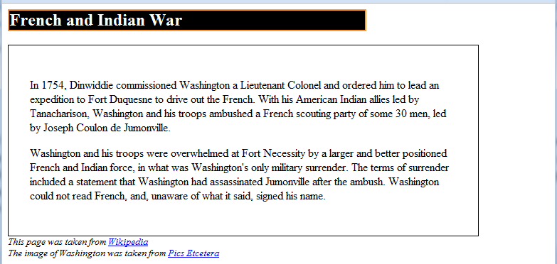

Incidentally, notice how the padding above and below the paragraphs seem to be more than 30 pixels (compare with the left side of the text). This can be explained by recalling that <p> tags give an additional line of space after the end of the paragraph. So above and below the paragraphs you are seeing the blank line plus the 30 pixels of padding.

The complete code:
<html>
<head>
<title>French and Indian War</title>
<style type="text/css">
h2 { background-color:black; color:white; border:2px solid #FF9933;
width:500; }
#maincontent { width:600; border:1px solid; padding:30px}
#citations { font-style:italic; font-size:80%; }
</style>

</head>
<body>
<div id="title">
<h2>French and Indian War</h2>
</div>
<div id="maincontent">
<p>In 1754, Dinwiddie commissioned Washington a Lieutenant Colonel and ordered him etc, etc, etc.</p>

<p>Washington and his troops were overwhelmed at Fort Necessity etc etc.</p>
</div>

<div id="citations">
This page was taken from <a href="www.wikipedia.org">Wikipedia</a><br />
The image of Washington was taken from <a href="???">Pics Etcetera</a>
</div>
</body>
</html>

Applying padding and margins to each of the four sides independently
When setting padding or margins, you have the option of applying the style individually to the top, bottom, right, or left of the box. For example:
padding-top:20px; padding-right:50px; margin-bottom:30px; etc, etc

Shorthand: There is a terrific shorthand for setting all four values at once:
padding:10, 20, 0, 30;
This sets all four values in the order: Top → Right → Bottom → Left. So in this example, the top padding is set to 10, the right to 20, the bottom to 0 and the left to 30.

If it helps you to remember, begin at the top and then move clockwise.

Again, this can be used both for padding and for margins.

An Important Reminder
This is a good time to remind you of the “with power comes responsibility” mantra that is so important to remember when learning CSS. CSS allows the designer a tremendous degree of control over the appearance of their page. Yet as a result, all kinds of strange things can take place. Consider this example in which I also apply a height property to the first paragraph…

<p style="width:400; height:70; border:solid">In 1754, Dinwiddie commissioned Washington....

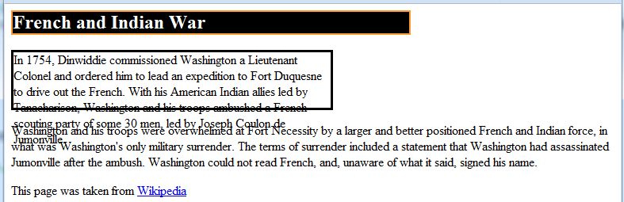

I won’t go into the specifics of why this occurred, but for now, it’s important to remember that you should frequently refresh your page to see the effects of your styles. Sometimes, a style can affect content in other, seemingly unrelated parts of your page. (If you are interested in why this occurred, Google or Bing or whatever… “CSS and overflow”).

For now use the following rule of thumb: When planning to apply a ‘height’ style – reconsider! It is frequently misused and often leads to strange results, particularly when used with different browsers. Height typically only needs to be used in specific situations. I’ll show you one example a little later, but for the most part, height should be used with caution.

In other words, there are all kinds of quirks that can pop up unexpectedly. This is not necessarily a bad thing; as long as you understand the underlying concepts, most of these snafus are usually easily remedied. However, you do need to be aware that depending on different browsers, screen resolutions, screen sizes, window sizes, etc, etc, the appearance of your page can and will change. Expert web designers spend a great deal of time attempting to control for these inconsistencies.

Containing Elements
Every element is inside a container. By default, the container for every element on your page is the <body> section. This container can be thought of as the browser window.
However, consider the use of your <div> sections: Each <div> section becomes the container for everything inside of it. This becomes very important particularly when dealing with layouts.
Consider the following section on percentages:

Using Percentages with Containing Elements
When percentages are applied to width, margins, padding, etc, the percentage applies relative to the container. Recall that by default, the container of every element is the browser window. In this case, the percentage is taken relative to the width of the browser window. So if the browser window is 760 pixels wide, then a margin of 10% would give you a 76 pixel margin. However, the more accurate way to understand percentages is in terms of the containing element.

For example, suppose you have a paragraph of text inside of a div element (the red block). Now suppose that div element has a width of 500 pixels as shown here. If you applied a width of 50% to your paragraph inside the div, that 50% would be relative NOT to the browser window, but rather, to the CONTAINING ELEMENT (i.e. the 500 pixel wide div tag). In other words, the width of this paragraph is 50% of its CONTAINER (i.e. the ‘div’)

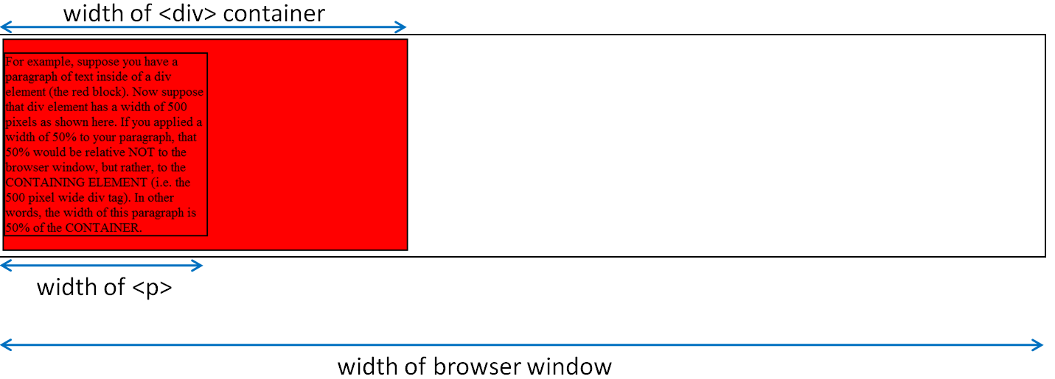

Here is the style followed by the relevant HTML code:
#outerblock { background-color:red; border:2px solid; width:500px; }
#somecontent { width:50%; border:2px solid;}

<div id="outerblock">
<p id="somecontent">For example, suppose you have a paragraph of text inside of a div element (the red block). Now suppose that div element has a width of 500 pixels as shown here. If you applied a width of 50% to your paragraph, that 50% would be relative to the DIV tag, NOT to the browser window since the container for the paragraphs is the <div> section. In other words, the width of this paragraph is 50% of the CONTAINER.</p>
</div>

Backgrounds and containers
Background colors and images are applied to their container, not to the page itself. For example, if you specify an image for a given <div> tag, then the background image will be visible only in that <div> section (also known as a container). However, if you specify a background-image for the <body> tag, then the image will display through the entire page.

Relative vs Absolute Positioning
There are a few different types of positioning, but the two most important at this stage are called relative and absolute. Absolute positioning allows you to position a block at specific coordinates within the container (which, by default, is the browser window). Relative positioning means you move the block relative to its current position in the document.

To apply fixed or absolute positioning, you first need to notify the page that you are going to do so. The property is called ‘position’ and the two most commonly used values are ‘relative’ and ‘absolute’. (Others, which we won’t discuss here, include ‘fixed’, ‘static’, and ‘inherit’.)

As an example, study the code in which I wish to do the following:
- I want to add a picture of Washington
- I want to place this picture to the RIGHT of my main content
- I want the box containing my main content (i.e. the paragraphs of text) to match the height of my image. (To do so, I have to find out the height of my Washington image. I checked, and it is 293 pixels in height).
- I want to remove the border around my main content and instead give it a background color
- I want my title to be the same width as my content

Here is my objective:
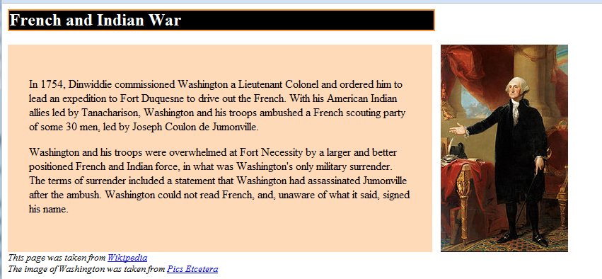

Here is how I accomplished it:
- Recall that we wanted the main content to be 600 pixels in width. However, because we later have added 30 pixels of padding (on both the R and L sides), I have reduced the declared width of the maincontent box to 540 pixels. (540 + 30 + 30 = 600 pixels total width.)
- The image was inserted in the usual manner (using the <img> tag). It was placed 600 pixels to the right by giving it an absolute position of left 620 pixels. The additional 20 pixels were for some “breathing room”. Note the white space between the maincontent box and the image.
- The height of the image was checked and the height of my maincontent box was adjusted to match that height. Again, one must not forget to factor in the total of 60 pixels of padding at the top and bottom. So because I want my box to be 293 pixels high, and we have 60 pixels of padding, I had to set the declared height of the maincontent box to 233 pixels. (Yes, this is one examle of proper usage of the ‘height’ property).
- The #title contextual selector was also changed to 600 pixels to match the width of the maincontent box.

Here is the code:
<html>
<head>
<title>French and Indian War</title>
<style type="text/css">
#title { background-color:black; color:white; border:2px solid
#FF9933; width:600; }
#maincontent { width:540; padding:30px; height:233; background-
color:peachpuff; }
#citations { font-style:italic; font-size:80%; }
</style>

</head>

<body>
<div id="title">
<h2>French and Indian War</h2>
</div>

<img src="washington.jpg" style="position:absolute; left:620;" />

<div id="maincontent">
<p>In 1754, Dinwiddie commissioned Washington.....

Incidentally, notice how the image was NOT displaced in an up or down direction. When you apply a right of left positioning, it does not make any top or bottom changes. Similarly, if you applied only top or bottom, no changes would be applied right or left.

Finally, let’s suppose that I decided that I didn’t like the “breathing room” between the textual content and the image of Washington. In order to make the image of Washington flush with our textual content I simply need to change the positioning of the image from the 620 pixels highlighted above to 600 pixels. This will remove the 20 pixels of whitespace between the text and the picture.
<img src="washington.jpg" style="position:absolute; left:600;" />

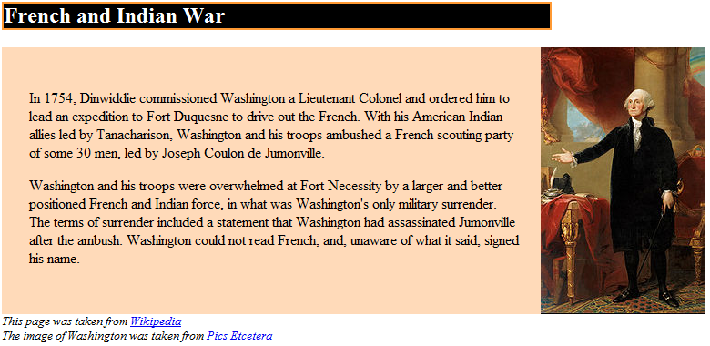

The ‘width’ property does NOT include extra borders / padding / margins:
When considering the size of a given box, the total size includes the declared width plus any padding plus any margins, plus the width of the border if one is present.

So the total width of our maincontent box is 600 pixels: 540 for the width plus 30 for right padding plus 30 for left padding. (There are no borders, so we did not have to include them in our calculation). This is why to get the image to begin immediately at the far end of the box, we had to move it over a total of 600 pixels.

Another way of saying this: The value you give to the width (or height) properties ONLY sets the amount of space holding the content (text, picture, etc). The height/width property does not include any additional pixels used by margins, padding, and borders.

Positioning the Box
There are four basic ways of positioning any box. We have just given an example of absolute positioning of a box. Here is a brief summary of the four types of positioning:
- Static: This means that box appears in the regular “flow” of the page. The HTML is displayed on the web page in the order in which your HTML was written in your editor. This is the default way of displaying content. It is the way that you have encountered throughout the course.
- Absolute location: where you specify its exact coordinates within the container.
- Relative location: where you specify the box’s location with respect to its current position on the page.
- Fixed location: You can specify where the box appears relative to the browser window itself.

The last three types of positioning are said to remove the box from the regular flow of the document. More on the subject of ‘flow’ shortly.

Elements are positioned using the top, bottom, left, or right properties. You can specify any or all of these properties you wish. For example:
h2 { position:absolute; left:100px; top:150px; }

Values can be specified in any units (pixels, ems, etc, etc), but the default is pixels.

In the real world, web designers typically use a combination of absolute and relative positioning. They also use a technique called ‘floating’. We have begun with absolute positioning as it is probably the easiest to work with but does have several downsides. We will return to it shortly, but first, we need to briefly discuss the concept of a document’s “flow”:

Removing an element from the “flow”
“Flow” refers to the default location of an element on the page. For example, if you write an <h2> element and then write an <img> element, then they will appear on the page in that order. However, once you position an element using either absolute or relative positioning, then you are removing that element from the regular flow of the document.

Positioning is a relatively easy way to place an element in a different location on the page. The problem is that the OTHER elements don’t know about it! In other words, if you’re not careful, the other elements on your page can and frequently will overlap with your newly positioned element.

Even with relative positioning, you do NOT move the element in terms of the element before or after it. You are simply adjusting the position of the element relative to its current location.

Remember that when you reposition an element, there is nothing stopping you from positioning the element on top of some other element. It’s up to you as the web designer to make sure this does not occur. I realize this may be confusing. That’s okay; most of these techniques take some time and experimentation before you can learn to really use them properly.

Relative Positioning
Take a look at the citations on our web page. To my eye, they feel a little bit “scrunched” up against the content just above. I will use relative positioning to move them down a little bit:

<div id="citations" style="position:relative; top:10px">
In this case:
- I first indicate that I wish to apply some relative positoning
- I then indicate that I wish to move the element down 10 pixels from its original location

Now you can see some additional white space:

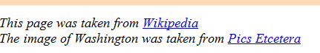

Again, be aware that surrounding elements are NOT affected by the new positioning of your element. In other words, for example, suppose there was an element (e.g. some H2 text) that came after our citations, this element would NOT be pushed downward by the relative displacement we just applied to our citations. See this example:

Absolute Positioning
When you define a position as being absolute, you are taking the element out of the normal flow of the document. For example, you may have typed the code for an element at the very top of your HTML document, but if you use absolute positioning, you can tell that element to appear way down towards the bottom of the page. We used absolute positioning earlier to move our image exactly 600 pixels to the right.

Just for kicks, I’ll change the property so that the image is only moved 550 pixels to the right and downward 30 pixels:

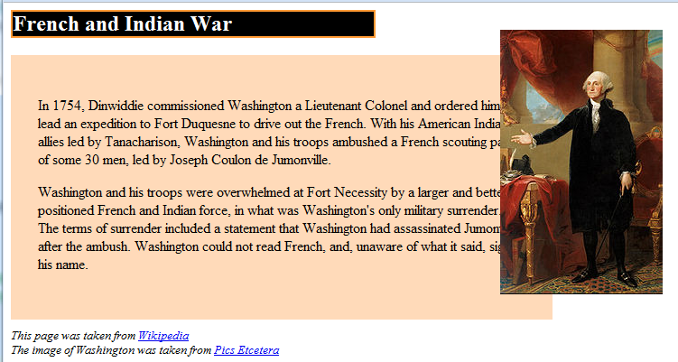

Wait a minute?! Moving the image only 550 pixels, as expected, caused the image to overlap with some of the material from our maincontent div section. But by applying the top:30px, shouldn’t the image have moved down??? The answer is that when you apply an absolute positioning, by default, this positioning occurs relative to the container which, in this case, is the browser window. Applying the right:550 moves the image that many pixels to the right of the browser window. Applying top:30 moves the image 30 pixels down from the top of the window. So while the image was initially well below 30 pixels from the top, the moment we applied an absolute position of top:30 we ended up with the result displayed here.

So, as always, remember that with power comes responsibility. Be sure to constantly refresh your page to see the results. Even seemingly innocuous changes can result in some very strange results. The problem is that once you’ve changed two or three styles, it can be difficult to go back and figure out just which changes were responsible. Things are much easier if the problem is noted immediately.

A warning about absolute positioning: Perhaps the main disadvantage to absolute positioning is that if the page is resized (e.g. grandma decides to increase the font size of her browser), there is a very reasonable chance that much of your layout will become completely skewed.

Again, an important and key point is that when you apply absolute positioning to an element, you remove the element from the regular flow of the document which means that it can overlap with other elements. This is not always bad—at times it is even intentional, but it’s something you need to be aware of.

At this stage in our study of layout, however, we will focus on absolute positioning and something called ‘floating’. As you advance, you will likely want to experiment with relative positioning as well.

Remember: Absolute positioning moves the block relative to its container

Another example: Consider a very simple site in which we place a simple image of a square using absolute positioning.

Step 1: We place a plain red box placed 50 pixels down and to the right of the upper right-hand corner of the browser window using absolute positioning:

<style type="text/css">
#outersquare { background-color:red; width:100px; height:100px;
position:absolute; top:50px; left:50px}
</style>

And in the body section:
<div id="outersquare">
</div>

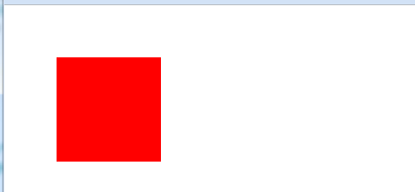

In this situation, the position of outersquare occurs relative to its container, which is the <body> section. Recall that the <body> section refers to the browser window.

Step 2: Now look what happens when we insert a yellow square inside the red square:
<style type="text/css">
#outersquare { background-color:red; width:100px; height:100px;
position:absolute; top:50px; left:50px}
#innersquare { background-color:yellow; width:30px; height:30px; }
</style>

<div id="outersquare">
<div id="innersquare">
</div>
</div>
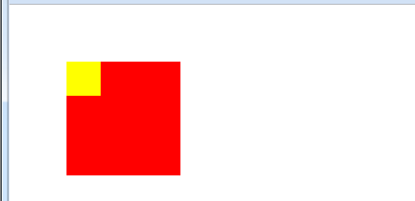

We did NOT tell the inner square to position itself absolutely 50 pixels down and to the right—so why did it appear there? The answer is that the innersquare is contained inside the outersquare. So the container of innersquare is NOT the browser window, it is outersquare.

To explain this a little further, let’s experiment by telling innersqure to be positioned 10 pixels down and 10 pixels to the right using absolute positioning. Because outersquare has been placed 50 pixels down and to the right, we might expect that innersquare will appear above and to the left. Instead, something else occurs…

Here is the code for innersquare:
#innersquare { background-color:yellow; width:30px; height:30px;
position:absolute; top:10px; left:10px; }

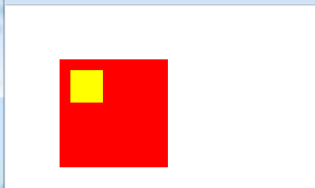

The reason for this behavior – and one that is very important to understand – is the following: When you apply absolute positioning, the coordinates you give (eg: 10 pixels from the top and 10 pixels from the right) apply relative to innersquare’s container. In this case, the inner (yellow) square’s div section: <div id="innerbox"> is enclosed in the red box’s div <div id="outerbox">. So, the 10 pixels down and right will begin based on the innersquare’s container (which is outersquare).

Another way of saying this: Since innersquare is contained inside outersquare, it “begins” wherever outersquare begins. Also, any positioning we apply to innersquare—even absolute positioning—will be relative to its container (outersquare).

So: Because the outer box is 50 pixels down and 50 pixels to the right, the inner box positions BEGINNING from 50 pixels down and to the right. In this case, it will be an additional 10 pixels down and to the right. If you’re keeping track, that would make it 60 pixels down and to the right of the browser window.

Here is the complete code for the display above:
<html>
<head>
<title>Absolute Positioning Test</title>
<style type="text/css">
#outersquare { background-color:red; width:100px; height:100px;
position:absolute; top:50px; left:50px}

#innersquare { background-color:yellow; width:30px; height:30px;
position:absolute; top:10px; left:10px; }
</style>
</head>
<body>

<div id="outersquare">
<div id="innersquare">
</div>
</div>
</body>
</html>

Don’t forget:
Unlike absolute positioning where the numbers you give move the document relative to its containing element, relative positioning occurs relative to the current location of the element.

Overlapping
When an element is positioned absolutely or relatively, you are removing that element from the regular flow of the page. When an element is removed from flow, it means that the normal sequence of one element followed by the next element, follwed by the next etc (ie: the way we are used to web pages working), no longer applies. Instead, you are basically plunking (for lack of a more technical term) that element at some specific position on the page. If another element happens to be occupying that space at the time, too bad! The newly positioned element will simply overlap and thereby obstruct the original element.

Floating Elements
Floating is great! Floating allows you to align an element to the right or left of its container. The great advantage to floating is that elements before and after will “float up” and wrap around your element. In other words, your floated element will not overlap with elements around it. That being said, you should be aware that having too many floats in a document can cause things to become unwieldy if you continue to exapnd the complexity of your page.

When beginning your study of floating elements, the most important thing to understand is that all boxes appear in your document one above the other. This may actually seem fairly obvious to you, but it’s still something you should be consciously tuned in to. In other words, the box containing an <h2> title sits above the box containing your first paragraph of text which sits above the box containing your second paragraph of text which is on top of the box containg a list which is on top of…

With floats, you can have a box align itself with either the right side of left side of the page. All elements that follow will “float up” and along side of the floated element. One important detail to recognize: If you are going to float an element, you will need to designate it to be of a lesser width than its container. In fact, CSS requires you to designate a width for all floated elements. (There is one exception: images to not have to have a designated width when they are floated as images already have a defined width).

Floats can be only with block-level elements. There is one important exception: Floats may also be used with the <img> tag - which is an inline element. In fact, one very common use of the float property is with the <img> tag to align an image to one side of the screen or the other.

Let’s do a little bit of practice with floating by using a basic page that has 3 distinct containers within the main browser window: a div containing the title, another div for the navigation links and a third div for the textual content. Here is the initial layout:

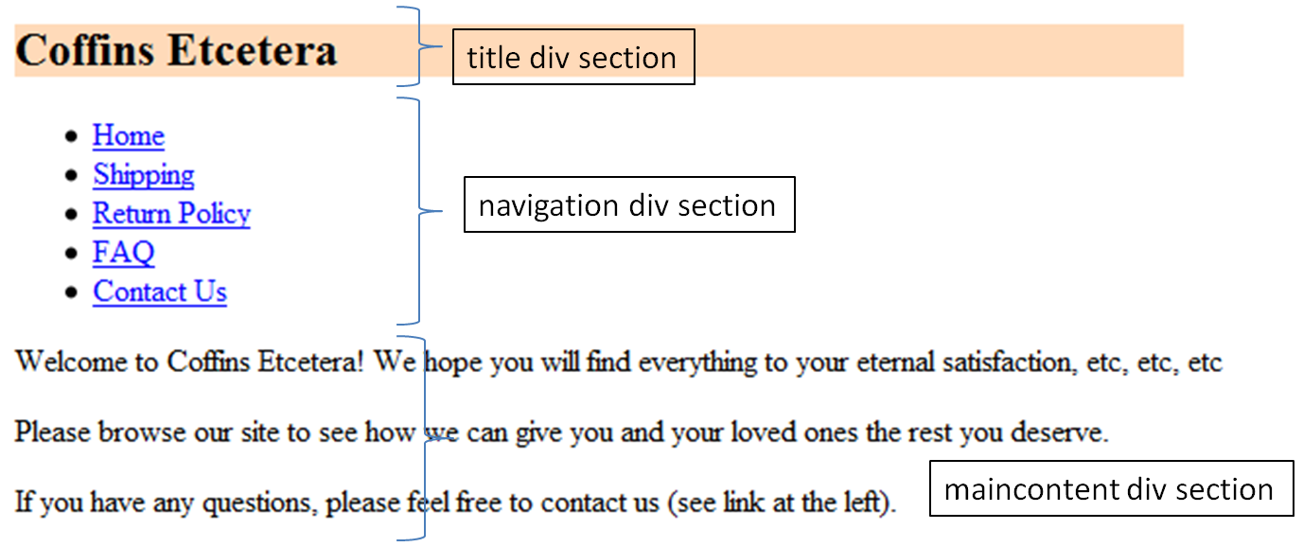

Here are embedded styles for the three sections (either semantic tags or divs):
nav { }
#maincontent { }
header { background-color:peachpuff; width:600; }

Now I will apply the very simple “float:left” to the navigation section.
nav { width:200px; border:2px solid; float:left; }

This will
- Tell the section to adhere to the left margin of its containing element (which in this case is the browser window). Aligning to the left margin is initally unremarkable since all elements are left-aligned by default. However, the float property will also:
- Tell every section that follows to float upwards and next to the floated element.

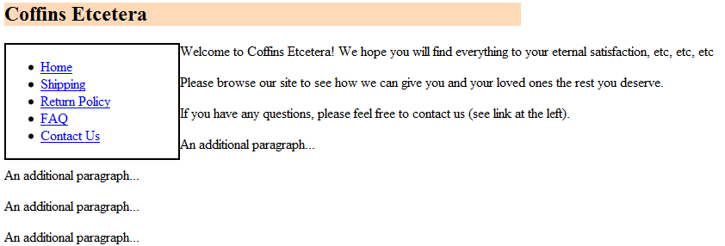

In this case, the content inside the maincontent section has floated upwards and along side of the nav section. (Before we applied ‘float’, the maincontent was displayed below the nav section).

Also note how once the content in our maincontent section went beyond the floated element (the “An additional paragraph”s), the content moves back to their usual left margins.

Incidentally, note how I also apply a border to the floated section. As has been mentioned a couple of times now, it is very helpful to help us see what our content is ‘doing’. I will remove this border later as it is not attractive.

Now I’ll make the following changes:
- Include an image which I’ll float to the right
- Include a border around most of the elements to make it easier to see what is happening. (Notice the duplication of embedded styles used to apply the borders – discussed below).

Here is a picture followed by the code:

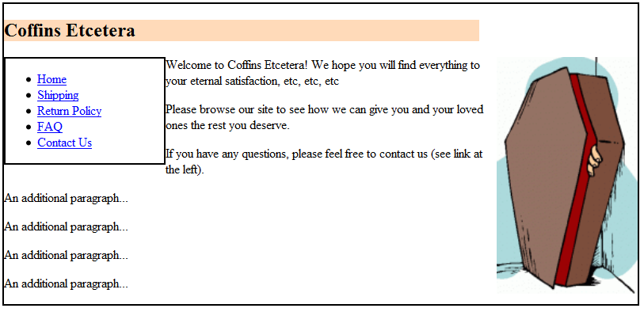

<style type="text/css">
body { width:800px; }
nav { width:200px; float:left; }
#maincontent { font-family:Arial; }
header { background-color:peachpuff; width:600; }
#coffinpic { float:right; height:300px; }

nav, body { border:2px solid; }
</style>

Duplicating Embedded Styles: The highlighted text shows how I have duplicated a couple of embedded styles: for the navigation id and the body selector. I could have included the border style directly the first time I wrote these embedded styles, but by duplicating them in the highlighted line, I can easily remove the borders later by simply deleting that line.

Now I’ll apply a few other styles and remove the borders. I’m the first to admit that this isn’t the most attractive page in the world…

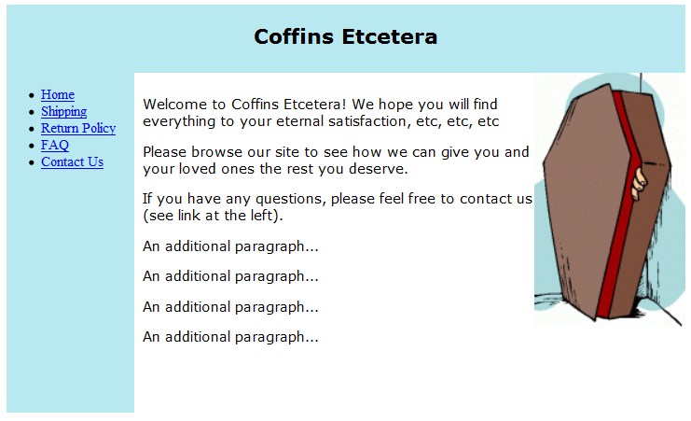

I have also applied a height property to the navigation section. By making the section extend downwards a little ways, I keep all of the maincontent from moving (rather awkwardly) back to the left margin. This is another of the very few ways you should use height for the time being: to extend the height of a floated element in order to keep adjacent content from wrapping below it.

Here are the styles:
<style type="text/css">
body { width:800px; }

header { background-color:#B8E8F0; padding:2 0 10 0; text-
align:center; font-family:Verdana; }
nav { width:150px; height:400px; float:left; background-
color:#B8E8F0; margin-right:10px; margin-top:0px; }
#coffinpic { float:right; height:300px; }
#maincontent {font-family:Verdana, sans; padding:10 40 10 40;
height:380px; }
#rightpic { height:500px; float:right; background-color:white; }

#coffinpic, header, nav, #maincontent { border:0px solid; }
</style>

Again, note the last line where I remove the border property to multiple sections at once. Reuse of embedded styles is the easiest way of quickly adding and removing borders while working on your layouts.

An important bit of float weirdness – borders & background:
Borders and backgrounds do NOT react to floating in the expected way. While the content inside the element floats exactly as you would expect, any borders or backgrounds will include the floated elements! In other words, the content (text, image, etc) will wrap around the float, but any backgrounds or borders will go right through (though underneath) the floated element.

There are reasons for this, and there are ways to get around it, but it’s something that you may encounter as you experiment. (Hint on fixing: Research the property overflow:hidden ).

Clearing Floats
The ability to tell an element NOT to float can be extremely helpful at times. Suppose you had a footer at the bottom of your page (e.g. a copyright notice) and you wanted it to stay there. Ie: You wanted to make sure that it never floats upward. You can apply the clear property to accomplish this.

The clear property has four possible values: left, right, both, none. none is the default value (i.e. it is how web browsers work normally), so it is rarely needed. The style clear:left tells the element to remain below any items that are floated left. However, if any elements have been floated to the right, then the cleared element will still float up. Similarly, clear:left tells the element to remain below any items that were floated to the right. If you want to make sure that elements floated on both sides are cleared, than you can simply apply: clear:both.

MISCELLANEOUS

The Box-Model – a quick review
CSS treats your web page as though every element is enclosed in an invisible box. Each box is made up of a border (invisible by default), a margin (empty space outside of the border), some content (e.g. text, pictures, etc) inside of the border. There is also something called padding which is the empty space between the margin and your text. Below is an example of such a box with these properties outlined. I’ve made the border visible to make it easier to see where the padding and margins are. In this case, the left margin is the empty space between the edge of the browser and the element. The padding is the empty space between the border and the content (the picture). In this example, I’ve written for a margin of 100 pixels and padding of 50 pixels:
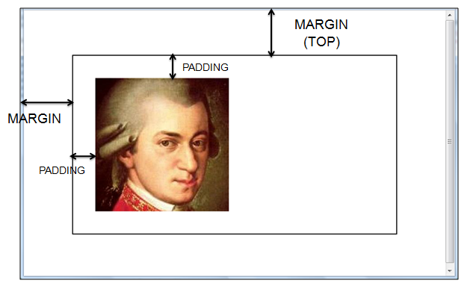

Pop-Quiz: Why is there white space present between the title and the maincontent sections below?

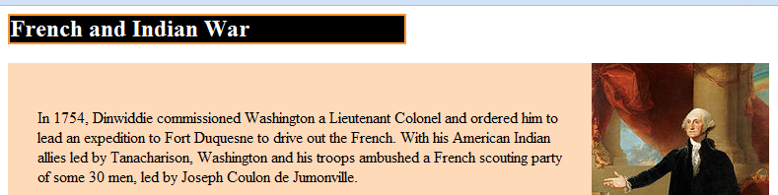

Answer: The whitespace comes from the margins around the <h2> element. Remember that margins are invisible—but present! If we were to apply the property margin:0 , to our h2 selector, this whitespace would disappear.

Pixels, Percents, and Ems oh-my! A Word on Sizes
It is important at this point to bring up the issue of units of measurement. Whenever you dictate a size of something to a web browser, the browser typically assumes the size to be in pixels. However, there are other units of measurement, and it is important that you understand at least the very basics of the main ones:
- Pixels: Pixels are nearly always (there are some exceptions) represent a single dot on the user’s screen. By default, most measurements are in pixels in CSS. Pixels tend to be the most predictable method of controlling size of elements on your page.
- Percent: Percentages refer to the percent of the user’s browser window. For example, if you set a given <h2> to be at 50%, then the block would take up half of the window. (Recall that by default, <h> elements take up the entire width of a window. If the browser resizes their window, then the element will also resize so that it still takes up 50% of the window.
- Em: Ems are units that represent the size of an upper case ‘M’ on a user’s screen. The advantage to using ems is that your elements will adjust based on whichever font the user has set for their browser. If, say, an elderly person has increased the font size on their browser, then your elements will adjust proportionally.

There are numerous advantages and disadvantages to each method, but we will not pursue them further in this course. Again, there is a multitude of resources available online and in any bookstore to which you can refer if you wish to pursue it further. For now, your best bet is usually to stick with pixels. Percentages, Ems and other units, while powerful, can behave in very strange ways if you don’t understand them well.

Collapsing/Colliding Margins - More CSS Weirdness
If you have two elements with defined margins, and those two elements are touching each other, then something very strange happens: The larger of the two margins simply overlaps the smaller margin! So if the upper element had a 20 pixel margin hanging down, and the element below had a 30 pixel margin sticking up, you will NOT get a total of 50 pixels of margin. Instead, you will only get the 30 pixel margin from the second element. The best workaround is probably to use padding on one of the elements to get the additional space. You will not be expected to worry about this for IT-130, but it is something you will encounter down the road if you continue to advance with CSS.

Where to go from here
There are countless books and online resources for learning about layout using CSS. One book that I thought had a short, but straight forward overview of the subject was ‘CSS: The Missing Manual’ by McFarland which seems to be in stock at many of the bookstores around town. Still, any book out there will likely suit you well. Just make sure you have something that’s been written with a copyright in the last couple of years at the most.

