First-Year Writing Digital Portfolio Pilot
Guiding Principles

Portfolios—paper or digital—support the learning outcomes for First-Year Writing in many ways, but especially in working with students to see reflection as knowledge production and as meaning-making activities.

Portfolios as reflective and assessment genres were introduced to higher education via composition and writing program administration in the early 1980’s (Belanoff and Elbow, 1986; Belanoff, 1991); in the decades since, enthusiasm for portfolios has never wavered—especially among writing teachers—but they have not found coherent and sustainable forms of programmatic and institutional adoption due to logistical challenges and resources needed to make such rich and contextual assessment practices viable and ongoing.

Portfolios continue to function as excellent dot-connecting mechanisms, however, for those of us committed to ongoing, meaningful reflective practice:

- What do we know about writing?
- How do we know it?
- How should we teach it?

Writing teachers and scholars also find portfolios and the practices around their design and distribution productive in terms of reflection (Yancey; Boyer), community building (Forbes), and professional development, especially in the context of teacher training (Anson). What has changed most dramatically in the subsequent decades, of course, are the technologies of literacy and the technology platforms that we increasingly use to do our textual and multimodal writing and composing. The generations of change in programmatic portfolio issues:

- First generation: portfolio concepts: collect, select, reflect, assess, and present; experimenting with media, but no real emphasis on technology. Rather, the emphasis is in purpose and audience.
- Second generation: medium → media; interests in interfaces; navigational options and preferences; links, principally internal.
- Third generation: external links; diversity of links; design, ethics, security
- Fourth generation: annotation of links—giving the appearance of context and context itself; different kinds of reflection, related to genre
- Fifth generation: repurposing, remediating; multimodality and mashup.

Digital portfolios are new neither in composition and rhetoric as a field, nor in the First-Year Writing Program at DePaul. In 2009-10 we collected a range of digital portfolios composed on a variety of platforms with productive results, especially in terms of understanding students’ literacy practices and identity formation; attention to revision and audience; and the use of graphic and textual arrangements in the presentation of their work in FYW courses.

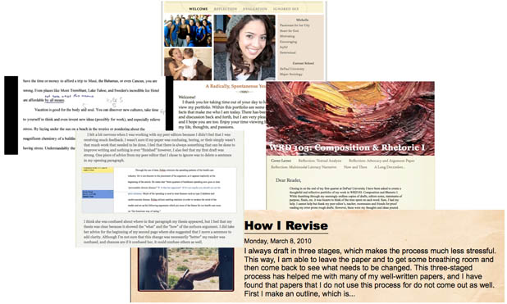

As we proceed, then, with a new digital-portfolio pilot project using the proprietary platform Digication, we want to draw on the same intellectual and pedagogical questions and contexts that we have already developed in the Department of Writing, Rhetoric, and Discourse locally, and for which disciplinary research provides productive and practical ways of aligning FYW learning outcomes with programmatic and institutional assessment, lifelong learning, literate practices in academic discourse, and multimodal composing. The First-Year Writing Digital Portfolio Working Group will attend to these issues first by helping to decide,

- What are purposes of the First-Year Writing Digital Portfolio – from the perspectives of students, teachers, and administrators?
- Who are the audiences for students’ digital portfolios?
- What should be included in students’ digital portfolios?
- Who will decide?
- What will it look like?
- What happens to the students’ digital portfolios after a course is over?
- What difference will students’ digital portfolios make?

Participants in the First-Year Writing Digital Portfolio Working Group will receive technical training from DePaul’s IDD staff, and will work with the department’s Technology & Pedagogy Coordinator, Michael Moore, to work out the contextual-planning issues, above; will create and share their own teaching portfolios, and will submit a Digital Portfolio Pilot Assessment Report, focusing on pedagogical contexts of use and assessment, to the Director of First-Year Writing before the conclusion of the Spring Quarter, 2011.

Working Group Resources

Anson, Chris M. "Portfolios for Teachers: Writing Our Way to Reflective Practice." Portfolio Assessment: Reflective Practice, Critical Theory, and Large-Scale Scoring. Ed. Laurel Black, Donald A. Daiker, Jeffrey Sommers, and Gail Stygall. Portsmouth, NH: Heinemann, 1994. 185-200.

Belanoff, Pat, and Peter Elbow. "Using Portfolios to Increase Collaboration and Community in a Writing Program." Portfolios: Process and Product. Ed. Pat Belanoff and Marcia Dickson. Portsmouth, NH: Boynton/Cook, 1991. 17-29.

Boyer Ernest. Scholarship Reconsidered: Priorities of the Professoriate. New York: Carnegie Foundation for the Advancement of Teaching, 1990.

Cambridge, Darren and Barbara Cambridge, Kathleen Blake Yancey, eds. Electronic Portfolios 2.0: Emergent Research on Implementation and Impact. Stylus, 2009.

Forbes, Cheryl. "Reading Portfolios Conversationally." New Directions in Portfolio Assessment: Reflective Practice, Critical Theory, and Large-Scale Scoring. Ed. Laurel Black, et al.. Portsmouth, NH: Boynton/Cook, 1994. 103-112.

Yancey, Kathleen. Reflection in the Writing Classroom. Logan, UT: Utah University
State Press, 1998.

Digital WRD:
http://composing.org/digitalwrd/student-perspectives-on-e-portfolios/
http://composing.org/digitalwrd/wrd-e-portfolio-platforms/
http://composing.org/digitalwrd/e-portfolio-classroom-planning/

