Social Media Identity: A Contextual Analysis  Does social media promote identity branding among young people?  Abstract  The purpose of this research is to investigate the relationship between teenagers and their  online identities. Social media has played a large part in the behavior and social structure of  individuals in the Y and Z generations. Being known as the “tech-savvy” generation, social  media has possibly influenced the formation of twisted self-identities among these technology educated teenagers. It seems as if more teenagers are using social media as an outlet for  personal branding and self-promotion, and it is affecting the way their true identities are  displayed and acknowledged by parents, sociologists, psychologists, educators, and their  peers. What can we learn by analyzing young individuals interactions among social media  and the effect it will have on their future social lifestyles?  In the 1st draft of the essay, this paragraph was …. Lorem ipsum dolor sit amet, consectetur adipiscing elit, sed do eiusmod tempor incididunt ut labore et dolore magna aliqua. Ut enim ad minim veniam, quis nostrud exercitation ullamco laboris nisi ut aliquip ex ea commodo consequat.  In today’s social media culture the concepts of fame, popularity, and the number of  “likes” a status or picture holds importance to teens. Young people around the world  spend countless hours on social media sites tweeting, instagramming, and snapchatting  their everyday lives. From instagraming their most recent vacation, to their new haircut,  teenagers in today’s culture appear to utilize social media as a tool to market their  personal identity to their ever-growing number of followers and online “friends.”  Getting the most “likes” or “favorites” is important, and essentially determines ones’  level of “insta-fame” or their social media status. This social media craze raises concerns  for the future of these book-deprived teens, and worries their parents even more.  However, while educators and parents fear the future, sociologist and psychologists rave  about the identity-branding trend that social media possibly promotes. Nevertheless,  social media is changing the way people communicate and behave throughout the world.  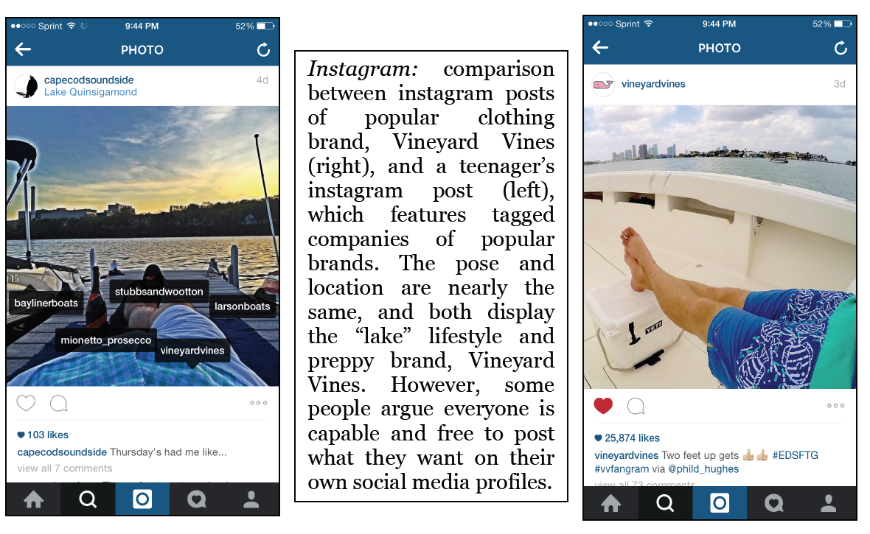  The discussion of identity requires an examination of a more detailed, and larger social  context. Businesses constantly brand their own identity through social media accounts,  but are young people today mirroring marketers social media behavior and selfbranding  themselves off their own social media profiles? Examples include instagram  controlled teenage girls who put all their energy into producing a post that captures  optimal likes and reactions from followers in order to display their “personal style” or  brand. Similar to these users, people frequently theme their social media profiles based  on a certain style or trend. For example, many young people look up to celebrities, and  often style themselves or wear brands their favorite celebrities model, but then proceed  to mock their lifestyle via social media. Teenagers also may mislead their social media  friends/followers into believing their online identities vs. their true face-to-face  identities. These trends are apparent throughout social media culture and raise the  question whether social media promotes identity branding among young people?  Looking at a bigger picture, what can we learn by analyzing young individuals interactions among social media and the effect it will have on their future social  lifestyles?  [But, What is Identity?] :  According to the Oxford English Dictionary, identity is defined as, “The quality or condition of being the same in substance, composition, nature, properties, or in particular qualities under consideration; absolute or essential sameness; oneness” (OED). It could also be referred to as, “The sameness of a person or thing at all times or in all circumstances; the condition of being a single individual; the fact that a person or thing is itself and not something else; individuality, personality” (OED). Is social media promoting  teenagers true identities through their personal profiles? Are young people’s self-identities consistent throughout social  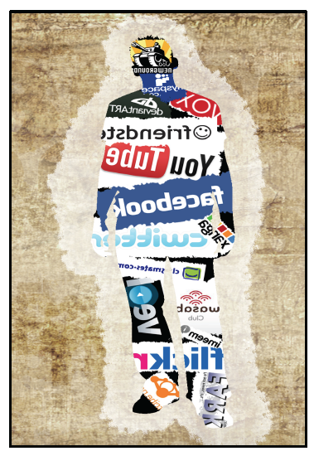  media and direct communication? Is identity branding through social media effecting how individuals socially express themselves?  Relating to the question, what is identity? The article, “Who am I? Self Identity –  Building Personal Character” summarizes concepts of self-identity and self-esteem,  author Andrew Dobson explains that self-identity is “ the way you look at yourself and  your relationship to the world (Dobson). He claims that self-identify is essentially tied to  self-esteem, which is a “person’s overall evaluation or appraisal of her or his own worth  at any one point in time” (Dobson). Consider that a drop in confidence will lower selfesteem  in the short term, but a prolonged negative experience will produce a longer  term reduction of self esteem, yet at the same time a positive emotional experience will  increase the sensation. However, do they both have an equal impact on the use of social  media among the young generation? In short, people’s self esteem is determined by  their individual experiences and timing.  This paragraph gave me real trouble in my 2nd draft because …. Lorem ipsum dolor sit amet, consectetur adipiscing elit, sed do eiusmod tempor incididunt ut labore et dolore magna aliqua. Ut enim ad minim veniam, quis nostrud exercitation ullamco laboris nisi ut aliquip ex ea commodo consequat.  In relation to self esteem, the article, “Is Technology Stealing Our (Self) Identities” from  Psychology Today, Ph.D. Jim Taylor claims that technology is overcoming young  people’s true personalities and framing their self-identity based on social media and pop  culture. Taylor explains that in previous generations social forces that influenced our  self-identities were positive networks such as parents, peers, and school. These  networks sent healthy messages about how young people should behave. However,  Taylor argues that social media today has caused a shift from “expressing our selfidentities,”  and toward “constructing facades” based on how others will perceive an  individual, similar to the characteristics of Facebook and instagram. Taylor concludes  his theory outlining, “self-awareness and self-expression give way to impression  management and self-promotion” (Taylor). According to Taylor, identity recognition  through social media is entirely deceitful, and shows no hope for the future Y and Z  generations or “society”.  Assessing the social behavior of generations Y and Z, the book it’s complicated by Danah  Boyd claims that, “social media is not only a tool, it is a social lifeline” (Boyd p. 20).  Boyd, a youth technology researcher at Microsoft, Harvard, and NYU, describes the  social media environment as a social hangout where teens can communicate with  friends and become better versions of themselves. Chapter 1, “identity,” summarizes  teen’s behavior on social media and their ability to leave the physical world and create  on online identity, “enabling them to become better version(s) of themselves” (Boyd).  Similar to Taylor, Boyd explains that young individuals are utilizing social media as an  outlet of self-expression, and a way to create a social identity, whether it is real or not.  She explains this behavior as “people typing themselves into being” and that the  Internet frees people of the burdens to their physically embodied identities (Boyd).  Essentially Boyd is claiming that the Internet is a tool to express ones self-identity,  whether it is valid or not. However, would a false identity ruin an individual’s  acceptance in their social circle? If so, what would be the consequences of teenagers  being socially neglected due to their social media profiles?  While Boyd provides sensible explanation to young people’s social media identities, the  concept of identity formation is raised. According to This Emotional Life from PBS, “the  main goal of identity formation is to develop a clear sense of self” (PBS). This is done by  “trying on” different identities in various social situations and observing reactions, while  noting others reactions as well. An example of “trying on” different identities is  presented through the MTV show Catfish, which follows Facebook-formed relationships  in which partners have never met in person, usually because one side is presenting a  twisted self-identity on their social media profile.  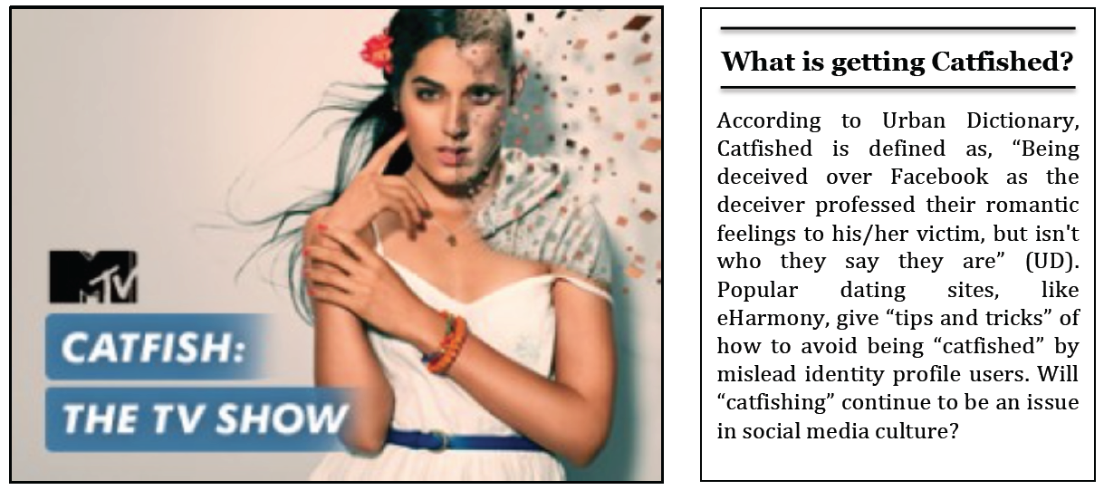  Erving Goffman further explains the concept of false identities in the Presentation of  Self in Everyday Life, which claims that, “when an individual interacts with others, they  are attempting to guide and create a certain image in which the other person sees them  and attains knowledge about them” (Goffman 40). This is observed not only in real time,  but also social media settings where individuals experiment with self-identity. Consider  the idea of being “catfished” by an individual who manipulated their self-identity toward  the other person’s preferences, and now has emotionally crushed another person due to  their false social media identity. Goffman is saying that social media users create their  twisted identities based off of what others expect from them, rather than their own  values and interests. Soraj Hongladarom, author of “Personal Identity and the Self in  the Online and Offline World” also connects with Goddman’s views and believes social  media crushes individualism. This is compelling because in today’s social culture, isn’t  everyone dying to be the unique, self-created individual that cares about nobody’s  opinion? | Process Description  What was supposed to happen in this Introductory ¶:  What actually happened:  What I tried to do in this ¶:  What I tried to do with this arrangement of text & images …  What was supposed to happen in this ¶:  What actually happened:  What I tried to do in this ¶:  What actually happened:  What was supposed to happen in this ¶:  What actually happened:  Transition ….  Conflicting claim -- what I tried to do in this ¶:  What was supposed to happen in this ¶:  What actually happened:  What I tried to do in this ¶:
What I tried to do in this Contextual Analysis Project, and what actually happened:

Lorem ipsum dolor sit amet, consectetur adipiscing elit, sed do eiusmod tempor incididunt ut labore et dolore magna aliqua. Ut enim ad minim veniam, quis nostrud exercitation ullamco laboris nisi ut aliquip ex ea commodo consequat. Duis aute irure dolor in reprehenderit in voluptate velit esse cillum dolore eu fugiat nulla pariatur. Excepteur sint occaecat cupidatat non proident, sunt in culpa qui officia deserunt mollit anim id est laborum. Lorem ipsum dolor sit amet, consectetur adipiscing elit, sed do eiusmod tempor incididunt ut labore et dolore magna aliqua. Ut enim ad minim veniam, quis nostrud exercitation ullamco laboris nisi ut aliquip ex ea commodo consequat.

